
QUALITY ALERT

Customer: United Date: March 16, 2023
Die: 15138 Colour: ALL COLORS
Type of Complaint: United REJECT

Q.A # Q.I.R # CUSTOMER NCR #

Description: United REJECT – Pieces is twisting causing NOT fit the JIG/ gripper when using automatic machine.
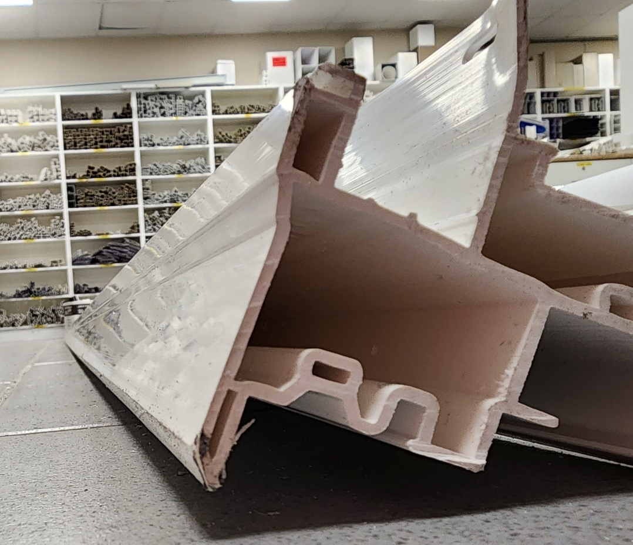

PLEASE MAKE SURE ANY PIECES HAVE GOOD SHAPE

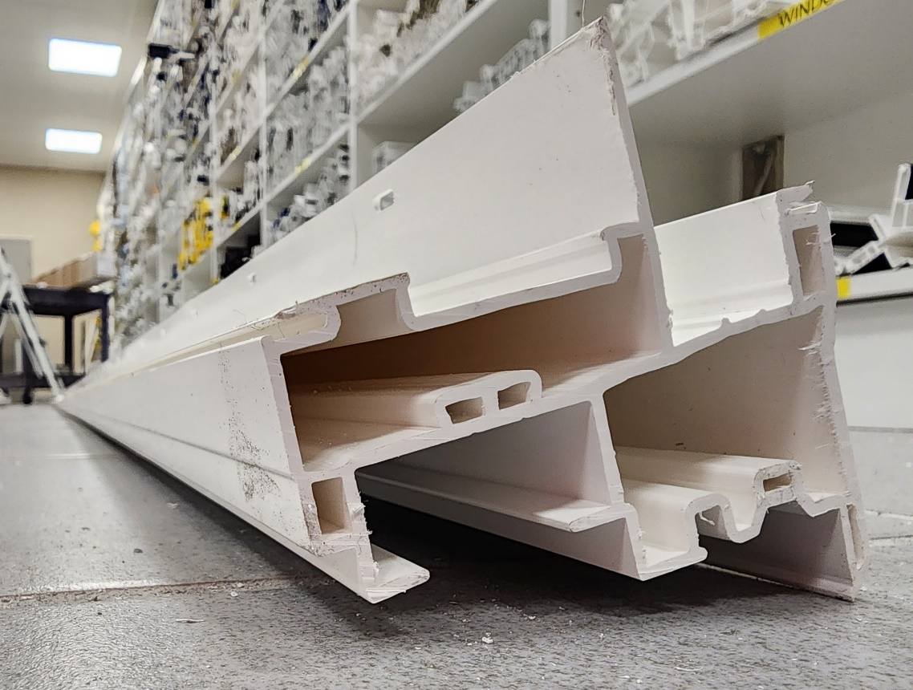

BY SIGNING BELOW, YOU ACKNOWLEDGE THE PROBLEM ABOVE AND AGREE TO MONITOR THIS ISSUE IN FUTURE PRODUCTION RUNS.
DAY SHIFT |  | AFTERNOON SHIFT |  | NIGHT SHIFT
NAME | SIGNATURE | NAME | SIGNATURE | NAME | SIGNATURE

